Systematics

Clade: Reptiles

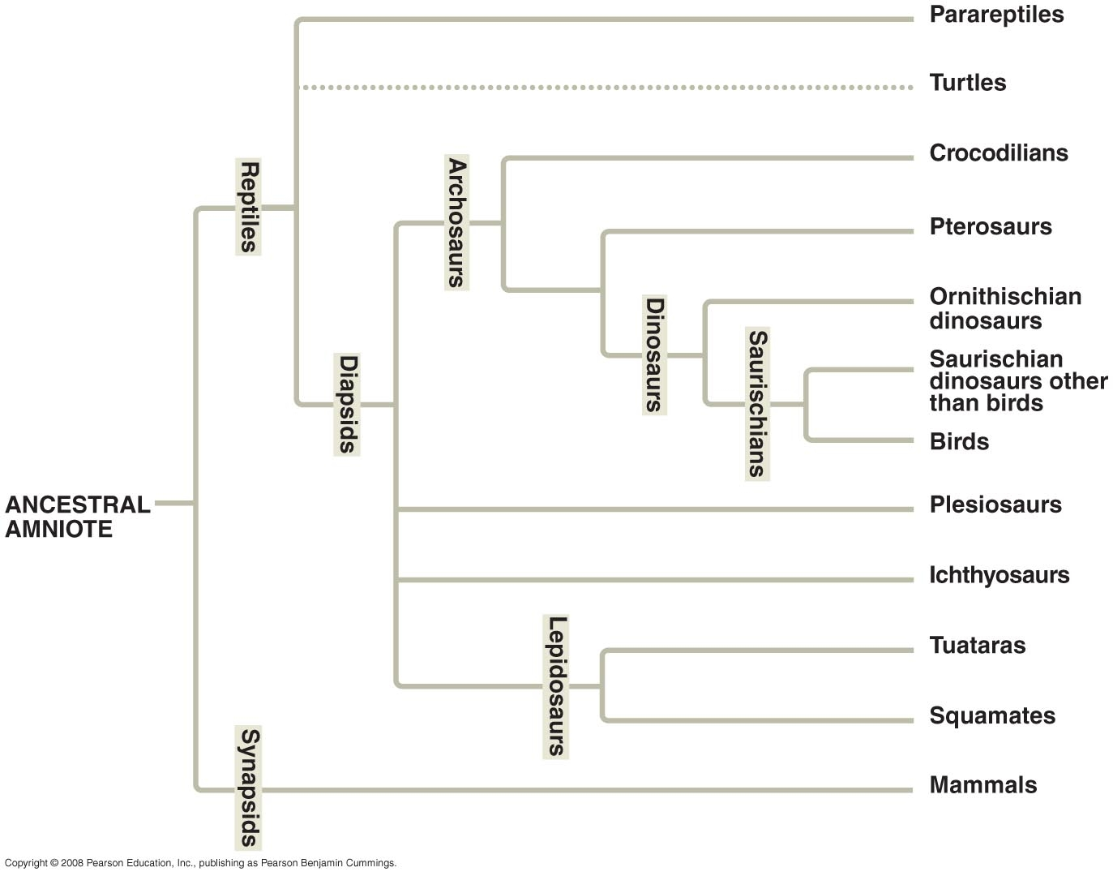

1. Identify the clade Reptiles. Circle the common ancestor.

2. List the groups that are descendants of the common ancestor:
Marsupial Moles and Placental Moles

Characteristics of both moles:
- Burrow through the ground
- Shovel-like front limbs
- Wedge-like heads as plows.
- Reduced eyes
- Reduced ears

Are these characteristics homologous or analogous? Explain your answer.

Construct a Cladogram:

You are chief astrozoologist on a Mars mission. After prospecting for several days, you assemble a collection of life forms. It is now your job to determine the evolutionary relationships between these organisms. Use the list of characters given with the table below. You decide Oliver should be your outgroup, because it appears to be the least specialized, and therefore probably most basal (at base of the tree).

Fill in the table. Use "0" to represent “character absent” and "1" to indicate "character present".
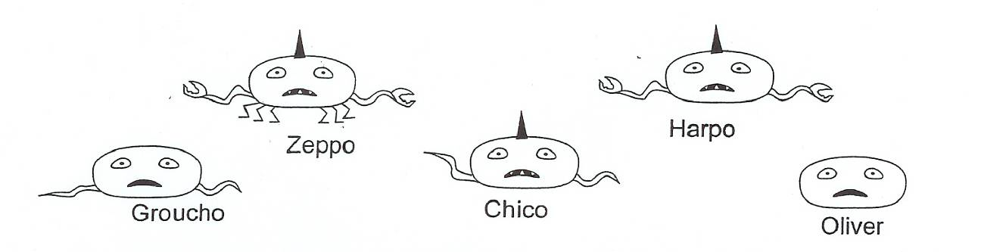

 | Oliver | Groucho | Zeppo | Chico | Harpo
1. eyes
2. mouth
3. tentacles
4. horn
5. pincers
6. legs
7. teeth

Construct the best cladogram based upon your table. (Note: If there are several different ways to make a cladogram, choose the simplest.)

Map all your characters.

